**Stress Detection Through Image Classification: A Comparative Study of Naive Bayes and Support Vector Machine**

**Mike Rasell Carale Dago-oc1**

Computer Science and Information Technology Department,

Bachelor of Science in Computer Science (BSCS)

Negros Oriental State University (NORSU), Negros Oriental, Philippines

|  |  |  |
| --- | --- | --- |
| **Article Info** |  | **ABSTRACT** |
| ***Keywords:***  Stress  Naïve Bayes  Support Vector Machine (SVM)  Inception-V3  Accuracy  Precision  Recall  F1-Score |  | This study explores the application of machine learning algorithms for classifying facial images into stressed and non-stressed categories. The dataset used comprises 355 facial images, sourced from Kaggle, of which a subset of 280 images (84 non-stressed and 196 stressed) was utilized due to hardware limitations. Pre-processing steps included image resizing to 299×299 resolution, normalization, and alignment with the input requirements of the Inception-V3 model for feature extraction. A comparative analysis was conducted between two traditional machine learning algorithms: Naive Bayes (NB) and Support Vector Machine (SVM). The models were evaluated using 10-fold cross-validation. The results indicated that the SVM model outperformed NB, achieving an accuracy of 82.86%, with precision, recall, and F1-score values of 0.8312, 0.8286, and 0.81, respectively. The NB model demonstrated an accuracy of 74.29%, with precision, recall, and F1-score values of 0.7797, 0.7429, and 0.75, respectively. These findings highlight the effectiveness of SVM for stress detection using facial images, though not reliable enough for real-world scenarios it still offers a promising non-invasive approach to stress monitoring and classification. |
|  |

1. **INTRODUCTION**

Stress has become a pervasive issue affecting individuals across various ages and professions. As of August 2024, 31% of adults surveyed worldwide believed that stress was the biggest health problem in their country, indicating a growing recognition of stress as a major health concern [1]. It is also reported that 51% of adults who felt stressed also reported feeling depressed, and 61% reported feeling anxious [2]. It indicates that higher levels of perceived stress are significantly associated with greater variability in negative emotional states, highlighting the complex relationship between stress and emotions [3]. Not only is stress related to the person's emotions, but it also negatively affects the person's body. Chronic stress can lead to high blood pressure, increasing the risk of heart attack and stroke, this shows that stress is also a significant risk factor for various cardiovascular conditions [4][5].

This study aims to make a machine-learning model that uses facial images as inputs to classify a person's emotional state whether the person is stressed or not stressed. While deep learning models have shown success in emotion recognition, simpler and interpretable machine learning models, such as Naive Bayes, Support Vector Machine, and Logistic Regression, remain underexplored in the context of stress detection using only feature-extracted facial images. Therefore, a comparison of these model's performance on stress classification is necessary to determine their viability and practicality in real-world applications. With this tool, stress can be detected early which can lead to timely interventions, improving quality of life and preventing adverse health outcomes. Additionally, traditional stress detection methods, such as surveys and biometric sensors, can be intrusive, expensive, or time-consuming [6][7]. This tool offers a non-invasive, cost-effective alternative that can be applied in real-time scenarios.

The rest of this paper is structured thus: Section 2 provides a detailed review of recent literature in the field of stress detection through image classification, Section 3 outlines the methodology employed in this study, and further provides a brief description of the machine learning algorithms used in this investigation. While Section 4 presents the results and discussion, and Section 5 concludes the research.

1. **LITERATURE REVIEW**

Stress detection has become a vital research area due to its implications for mental and physical health. While advanced deep learning techniques have dominated stress detection studies, there is still a lack of available research utilizing traditional machine learning (ML) methods like Support Vector Machine (SVM) and Naive Bayes (NB) specifically for stress detection using facial image classification. As such, this review focuses on papers related to stress detection through image classification, highlighting relevant methodologies, findings, and the potential applicability of traditional ML models.

**2.1. Stress Detection Using Machine Learning**

Machine learning models have been increasingly applied to stress detection, particularly through image classification, as a non-invasive and effective approach. In a study on understanding stress, researchers used a hybrid approach using 2 different datasets in parallel but complementary ways. The datasets both are sourced from Kaggle and they are: the Facial Recognition Dataset which includes facial images and the other is Student Stress Factors Dataset which are behavioral and contextual factors, such as workload and deadlines. Their study used three models in total, one for image classification which is a custom Convolutional Neural Network (CNN), and 2 for the classification of the Student Stress Factors Dataset, which are Random Forest (RF) and Support Vector Machines (SVM). But mainly this study will focus on reviewing their image classification study. Before extracting features of their image datasets they preprocessed it to improve the robustness of the model by resizing, normalizing, and augmenting the images. The datasets were split into 80% for training, 10% for validation, and 10% for testing, and after this, they used their custom CNN to extract the features and passed through it to classify images into stress levels. Overall their custom CNN model got a validation accuracy of 92% and a testing accuracy of 90% [10].

Another study achieved stress recognition by segmenting videos into 2-second clips and inputting facial images and facial landmark features using ResNet-18 as their model. The dataset used is the Yonsei Stress Image Database which includes over 2 million images of 50 subjects captured during various stress-inducing experiments, these stress tests were labeled: neutral, low stress, and high stress. The facial images of the 2-second clips were cropped from video frames and resized to 112×112 pixels, normalized, and blurred to address jitter effects, before embedding the images. The dataset was divided into training, validation, and testing sets in a ratio of 3:1:1 and a five-fold cross-validation method was employed to ensure robust performance evaluation. After classifying the images, the proposed method using ResNet-18 with spatial and temporal attention modules combined with facial landmark features achieved the best accuracy of 66.84% which outperformed alternatives such as VGG-16 and ResNet-50. This performance shows that it outperformed existing methods, including standard CNNs and handcrafted feature-based approaches [11].

Other researchers also used three Deep Convolutional Neural Networks (DCNN), which are VGG16, VGG19, and Inception-ResNet V2 in both extracting features and classifying the images after adding the DCNN classifier layers. They used datasets from three different sources which are from: Karolinska Directed Emotional Faces (KDEF), Extended Cohn-Kanade (CK+), and Net Images, which in total amount to 5235 images, which were then split to 80% for training, 10% for validation, and 10% testing. For feature extraction of the images, they used all three pre-trained models then they tested and added two types of classification layers for the final prediction of the image's class which are, Global Average Pooling (GAP) Classifier and Convolutional-Layer-Based Classifier. After fine-tuning, VGG16 with a convolutional layer-based classifier was the best-performing model with an overall accuracy of 89.6% and an f1-score of 89.7% [12].

1. **METHODOLOGY**

**3.1. Hardware and Software**

The study was carried out on a system running Windows 10 with a 64-bit operating system. The system uses an Intel Core™ i5-7400 CPU with 16GB Random Access Memory (RAM). The researchers utilized Jupyter and Python version 3.9.15 as the primary programming language for data analysis and model implementation with the following libraries: Math, NumPy, Pandas, PIL, OS, Scikit-Learn, Matplotlib, Seaborn, TensorFlow, and Keras.

**3.2. Data Acquisition**

This study employs a dataset from Kaggle which is the Stress Non-Stress Images dataset, a file with 355 jpeg files which are facial images categorized based on a person's emotional state which is Non-Stressed or Stressed. The Non-Stressed class includes emotions such as being happy and neutral, while the Stressed class includes emotions such as being sad and angry [13]. Because of hardware limitations, this study uses 280 images with 84 Non-Stressed and 196 Stress images.

**3.3. Image Embedding**

The main goal and objectives of the proposed system are to diagnose and make a tool that can identify whether a person is stressed through facial images. This study uses a Deep Convolutional Neural Network (DCNN) which is Inception-V3, for feature extraction of the facial images.

Inception models were developed by a researcher [14] for the first time in 2014. The structures of inception models and the conventional CNN model are different because they are inception blocks which means lapping the same input tensor with multiple filters and concatenating their results. In 2015, a researcher [15] proposed a new version of the inception models named Inception-V3, an improved version of the previous versions of inception models which are Inception-V1 and Inception-V2, and possesses 24M parameters. Inception-V3 improves the efficiency and performance of convolutional neural networks by introducing clever factorization techniques. Instead of directly using large convolutions (e.g., n x n), it breaks them into smaller, more manageable operations. For example, a 5 x 5 convolution is replaced by two 3 x 3 convolutions, and an n x n convolution is split into asymmetric 1 x n and n x 1 convolutions, reducing computation. Additionally, 7 x 7 convolutions are replaced with multiple 3 x 3 convolutions. Each inception block processes the input in parallel through multiple convolutional filters of different sizes (1 x 1, 3 x 3, and 5 x 5), as well as 3 x 3 max pooling, capturing features at various scales. These outputs are then concatenated and passed to the next module, allowing the network to learn complex features efficiently.

**3.4. Data Pre-processing**

Data processing is an essential aspect of model development. Data acquired in their raw form contain noise and anomalies, which can affect the performance and training process of the model being schooled. In addition to this when preparing input data for a DCNN, it's essential to adhere to specific requirements regarding input shape, color channels, and preprocessing steps to ensure optimal performance [17]. The researchers employed several techniques to clean the data, which included image pre-processing and data normalization:

Image pre-processing is an essential part of image classification to ensure that input images align with the model's expectations. Inception-V3 requires input images in 299x299 resolution and should also have three color channels (red, green, and blue) [18][19]. And since the image datasets have higher resolution than the required input, the image is resized to have a resolution of 299x299. After this, the image is preprocessed using TensorFlow Keras API preprocess_input so that the images align with the model's training conditions.

Data normalization is a pre-processing technique primarily intended to manage numerical features and is applied to numerical features before the application of classification algorithms. Normalization is crucial to prevent the effect of certain features from being concealed by others, particularly when the ranges of the features are inconsistent [20]. After feature extraction using Inception-V3, the features are normalized to improve model training [21]. The normalization techniques used are Min-Max Normalization for Naive Bayes (NB) and Z-Score Normalization for the Support Vector Machine (SVM).

**3.5. Machine Learning Algorithms**

This section focuses on the machine learning classification models utilized in this study. After image and data pre-processing, the machine learning workflow progresses to the model training stage, where an algorithm is taught to learn from data and produce predictions. This algorithm is specifically responsible for the classification of facial images whether the person is stressed. To find the best classifier for this task, two classifiers, which include Naive Bayes (NB) and Support Vector Machine (SVM) were tested through a variety of tests.

**3.5.1. Naïve Bayes**

The Naïve Bayes algorithm has its foundation rooted in the Bayes theorem by Thomas Bayes. One of the strengths of this model is its ability to handle missing values. And Unlike other models, Naïve Bayes conserves processing and training time [23][27]. The term ‘naive’ is used due to this algorithm's uncertain independence. With this, researchers in [24] stated that with this ability it's able to converge quicker when compared to several others.

(1)

Where P is the probability, X is the training set of attributes and Y is the given class [27].

**3.5.2. Support Vector Machine**

Support Vector Machine (SVM) is a binary linear classifier. As a non-probabilistic supervised learning algorithm, it utilizes training data and employs a high-dimensional space to construct a set of hyperplanes for data classification. While only the features of test data are provided, the model is trained on the training data to predict the target values. For effective classification of problem instances, SVM relies on selecting the optimal hyperplane [27].

**3.6 Model Evaluation Metrics:**

Evaluation measures are metrics used to assess the results of an experiment [25]. In the context of classification models, different evaluation metrics are used to measure their output. In this study, the main performance evaluation metric is “Accuracy”. However, additional metrics such as recall, precision, f-measure, and confusion matrices are also used to supplement the evaluation of the model's performance. Each model identifies learner engagement levels when assessed using these metrics. A brief description of these metrics is provided below.

Accuracy is a common evaluation metric for classification models. It's calculated as the ratio of well-predicted samples to the total sample of prediction. For a balanced dataset, accuracy is a reliable measure of the model's performance [24].

(2)

Where the numerator reflects the total number of correct predictions, while the denominator represents the total number of predictions made by the model. A higher accuracy value suggests that the model is more effective at correctly classifying both classes [27].

Precision measures the proportion of correctly predicted positive observations out of all the predicted positive observations. A high precision score indicates strong class predictions, while a low precision score reflects weak class predictions [24].

(3)

Where True Positives refer to the instances that were correctly identified as positive, while False Positives are the instances where the model wrongly predicted the positive class [27].

Recall is the ratio of correctly predicted positive results to all actual positive samples, also known as the detection rate. It's calculated by dividing the true positive samples by the sum of the positive samples [24].

(4)

Where False Negatives occur when the model mistakenly classifies a positive instance as belonging to the negative class [27].

F1-score is the mean value for recall and precision. It offers an indicator of mistakenly graded results [21]. It is regarded as the best metric for measuring the performance of models on an imbalanced dataset. It ranges from 0 to 1, with higher values indicating better model performance [24].

(5)

Where Precision evaluates the accuracy of positive predictions and Recall assesses the model's ability to identify all relevant instances, the F1-Score combines these two metrics into a single value, offering a balanced measure of the model's accuracy and completeness [27].

1. **RESULTS AND DISCUSSION**

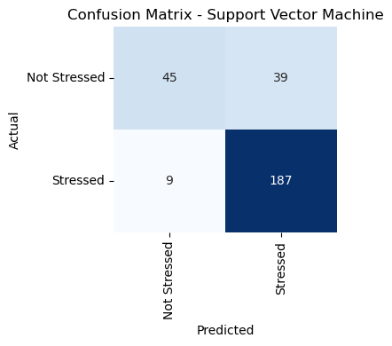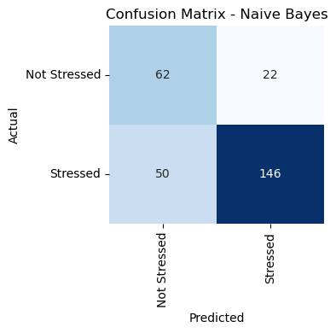**4.1. Confusion Matrix**

In Figure 2, the confusion matrix for the SVM model shows that it performs well in classifying the “Stressed” class with a high true positive count (187) and a low false negative count (9), which indicates strong recall for the stressed class. However, it struggles more with the “Not Stressed” class, as seen in the higher number of false positives (39), where “Not Stressed” was misclassified as “Stressed”. Overall, SVM seems better at identifying “Stressed” instances than “Not Stressed” ones, which might suggest a bias towards the “Stressed” class.

**Figure 3.** NB Confusion Matrix

**Figure 2.** SVM Confusion Matrix

In contrast in Figure 3, NB shows better performance in identifying the “Not Stressed” class compared to SVM, with more true negatives (62) and fewer false positives (22). However, it performs worse for the “Stressed” class, as it has a lower true positive count (146) and a much higher false negative count (50) than SVM. This suggests Naive Bayes might underperform in capturing “Stressed” instances, potentially due to its assumption of feature independence, which may not hold well in this dataset.

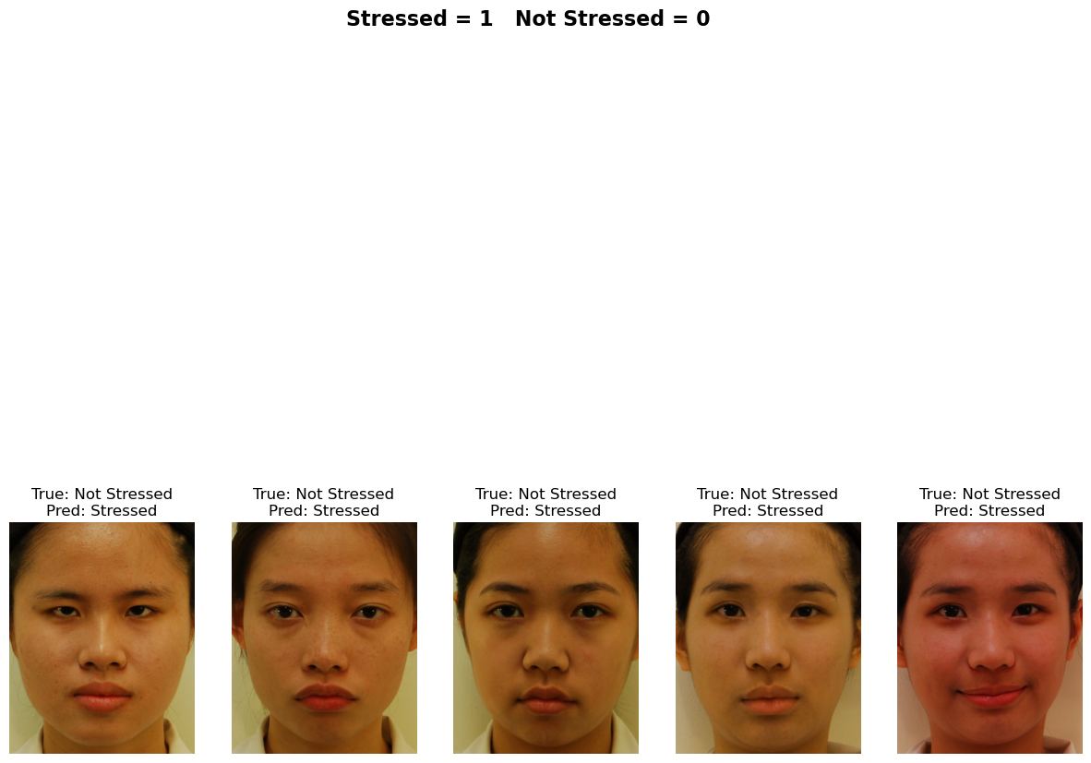**4.2 Misclassified Image Analysis**

SVM has a consistent misclassification of “Not Stressed” as ”Stressed”. This suggests the model is overly sensitive to features it associates with stress like certain facial expressions, redness, or tension in the face, leading to false positives. The model might also be picking up on specific features such as slight frowns, facial asymmetry, or other expressions, which may not truly indicate stress but are being interpreted as such by the SVM. And since the expressions in the “Not Stressed” category appear ambiguous or might share similarities with features the model associates with stress, like redness in the face, this contributed to the misclassification. Also in some images redness or lighting variations might be interpreted by the model as stress, even when it’s unrelated.

**Figure 4.** SVM Misclassified Images

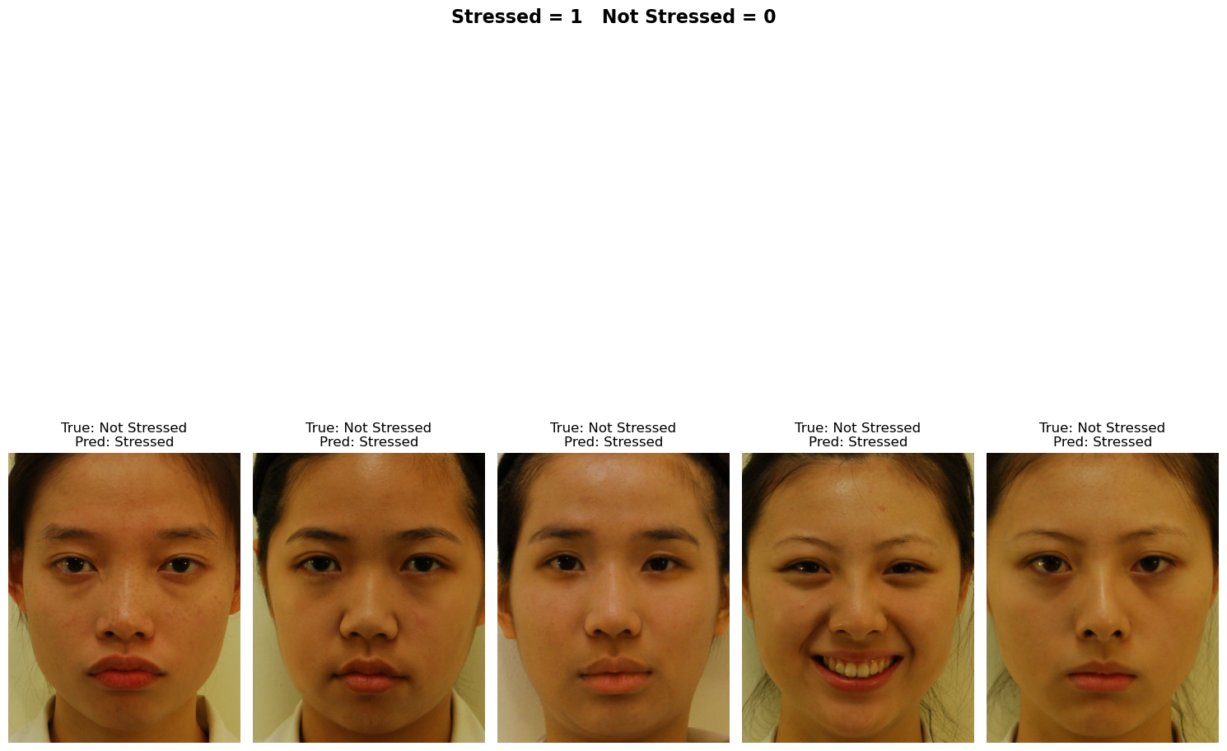 NB mostly misclassified “Stressed” images as “Not Stressed” which is the opposite of SVM. This shows that some faces lack common stress indicators like furrowed brows and tensed jaws, making it harder for the model to distinguish. And in the misclassified “Not Stressed” images as”Stressed”, because of misleading cues. For instance, intense facial expressions or lighting effects may have contributed to false positives. The misclassifications from NB also appear more random or less pattern-dependent compared to SVM, which uses a decision boundary to classify. This shows that the misclassification rate is due to its inability to model feature dependencies. Stress indicators like furrowed brows and mouth tension are likely correlated, and NB cannot effectively handle these interdependencies. NB tends to be simpler and faster, though it lacks the complexity required for nuanced tasks like facial expression analysis.

**Figure 5.** NB Misclassified Images

**4.3. Model Performance**

**Table 1**. Performance Metrics

|  |  |  |  |  |
| --- | --- | --- | --- | --- |
| Models | Accuracy | Precision | Recall | F1-Score |
| SVM | 0.8286 | 0.8312 | 0.8286 | 0.81 |
| NB | 0.7429 | 0.7797 | 0.7429 | 0.75 |

In the evaluation of the two machine learning models using a 10-fold cross-validation, in Table 1 it can be observed that the performance of all the model's accuracy ranges from 74% to 83%. The result shows that all the models can identify whether the facial images of the subject are stressed. And with a thorough analysis of the results, indicates that SVM provided the highest accuracy of 82.86%, with a precision of 0.8312, a recall of 0.8286, and an F1-score of 0.81. The NB model, underperformed showed lower accuracy compared to SVM, with an accuracy of 74.29%, a precision of 0.7797, a recall of 0.7429, and an F1-score of 0.75. These results suggest that SVM outperforms Naive Bayes across all metrics, suggesting it is better suited for this task. The higher accuracy and balanced precision-recall values make it more reliable. While NB still performs reasonably well, it underperforms compared to SVM due to its simplicity.

1. **CONCLUSION**

The SVM model demonstrates good overall performance in the image classification task, achieving consistently high metrics around 81-83%. The model effectively identifies “Stressed” images but struggles with “Not Stressed” images, leading to high false positives and low precision for this class. In its current state, the model may not be reliable enough for real-world scenarios where correctly identifying "Not Stressed" individuals is critical.

While the NB model exhibits lower performance compared to SVM with metrics ranging between 74–77%. It is more balanced compared to SVM in identifying both classes but tends to miss “Stressed” cases while performing better for the “Not Stressed” class. It also has higher misclassification rates due to its inability to model feature dependencies. Stress indicators like furrowed brows and mouth tension are likely correlated, and NB cannot effectively handle these interdependencies. Overall, NB underperforms in this case because the facial features extracted are unlikely to be independent, and the assumptions of NB may not hold true.

This study confirms that stress is a complex state and can manifest in ways not easily captured in static facial expressions alone. This might explain why the models struggle to distinguish between subtle cases of stress and non-stress. This study also confirms that SVM is the most effective model for classifying facial images if the person is stressed, this is expected since SVM handles complex, high-dimensional data like Inception V3 features better.

**REFERENCES:**

[1] Statista, "Stress as a top health concern worldwide 2023," Jan. 2025. [Online]. Available: https://www.statista.com/statistics/1498280/stress-as-a-top-health-concern-worldwide/. [Accessed: Jan. 20, 2025].

[2] Mental Health Foundation, "Stress statistics," [Online]. Available: https://www.mentalhealth.org.uk/explore-mental-health/statistics/stress-statistics. [Accessed: Jan. 20, 2025].

[3] National Center for Biotechnology Information, "The Relationship between Psychological Stress and Emotional State in Chinese University Students during COVID-19: The Moderating Role of Physical Exercise" PubMed Central, [Online]. Available: https://pmc.ncbi.nlm.nih.gov/articles/PMC10001233/. [Accessed: Jan. 20, 2025].

[4] American Heart Association, "Chronic stress can cause heart trouble," Feb. 4, 2020. [Online]. Available: https://www.heart.org/en/news/2020/02/04/chronic-stress-can-cause-heart-trouble. [Accessed: Jan. 20, 2025].

[5] National Center for Biotechnology Information, "The effects of stress on physical health and its implications," PubMed Central, [Online]. Available: https://pmc.ncbi.nlm.nih.gov/articles/PMC7603890/. [Accessed: Jan. 20, 2025].

[6] MDPI, "Electronics | Free Full-Text | A New Era in Stress Monitoring: A Review of Embedded Devices and Tools for Detecting Stress in the Workplace," [Online]. Available: https://www.mdpi.com/2079-9292/13/19/3899. [Accessed: Jan. 20, 2025].

[7] National Center for Biotechnology Information, "Stress: Concepts, Cognition, Emotion, and Behavior," PubMed Central, [Online]. Available: https://pmc.ncbi.nlm.nih.gov/articles/PMC6749249/. [Accessed: Jan. 20, 2025].

[8] G. Theophilus and C. I. Eke, "Machine learning-based e-learners' engagement level prediction using benchmark datasets," Int. J. Appl. Inf. Syst., vol. 12, no. 41, Sept. 2023.

[9] V7 Labs, "Pattern Recognition Guide," [Online]. Available: https://www.v7labs.com/blog/pattern-recognition-guide. [Accessed: Jan. 20, 2025].

[10] IJRASET, "Stress Detection in IT Professionals Using Machine Learning," [Online]. Available: https://www.ijraset.com/best-journal/stress-detection-in-it-professionals-using-machine-learning. [Accessed: Jan. 20, 2025].

[11] National Center for Biotechnology Information, "The Impact of Stress on Health: A Review of the Literature," PubMed Central, [Online]. Available: https://pmc.ncbi.nlm.nih.gov/articles/PMC8625615. [Accessed: Jan. 20, 2025].

[12] ScitePress, "Stress Detection Using Machine Learning: A Review," [Online]. Available: https://www.scitepress.org/PublishedPapers/2021/104742/104742.pdf. [Accessed: Jan. 20, 2025].

[13] P. Bhagat, "Stress vs Non-Stress Images Dataset," Kaggle, [Online]. Available: https://www.kaggle.com/datasets/preritbhagat/stress-non-stress-images. [Accessed: Jan. 20, 2025].

[14] C. Szegedy, W. Liu, Y. Jia et al., “Going deeper with convolutions,” Technical report, Cornell University, New York, NY, USA, 2014.

[15] C. Szegedy, V. Vanhoucke, S. Ioffe, and J. Shlens, “Rethinking the inception architecture for computer vision,” 2015, https:// arxiv.org/abs/1512.00567.

[16] University of Rochester Medical Center, "Stress and Your Health," [Online]. Available: https://www.urmc.rochester.edu/encyclopedia/content?ContentID=2171&ContentTypeID=1. [Accessed: Jan. 20, 2025].

[17] Cmrad, "The Ultimate Guide to Preprocessing Medical Images: Techniques, Tools, and Best Practices for Enhanced Diagnosis," [Online]. Available: https://about.cmrad.com/articles/the-ultimate-guide-to-preprocessing-medical-images-techniques-tools-and-best-practices-for-enhanced-diagnosis. [Accessed: Jan. 20, 2025].

[18] Keras, "InceptionV3: Pre-trained model for image classification," [Online]. Available: https://keras.io/api/applications/inceptionv3/. [Accessed: Jan. 20, 2025].

[19] PyTorch, "Inception V3 | PyTorch," [Online]. Available: https://pytorch.org/hub/pytorch_vision_inception_v3/. [Accessed: Jan. 20, 2025].

[20] M. C. M. Pasague, "Classifying Garbage Images: A Comparative Study of Naive Bayes, SVM, and Logistic Regression Models," Bachelor of Science in Computer Science, Negros Oriental State University, 2025. [Online]. Available: cristinapasague27@gmail.com.

[21] MDPI, "Deep Learning for Stress Detection: A Survey," Healthcare, vol. 6, no. 2, p. 11, [Online]. Available: https://www.mdpi.com/2306-5729/6/2/11. [Accessed: Jan. 20, 2025].

[22] Analytics Vidhya, "Feature Scaling in Machine Learning: Normalization & Standardization," [Online]. Available: https://www.analyticsvidhya.com/blog/2020/04/feature-scaling-machine-learning-normalization-standardization/. [Accessed: Jan. 20, 2025].

[23] E. F. Buraimoh, “Predicting Student Success Using Student Engagement in the Online Component of a Blended-Learning Course,” pp. 1–65, 2021.

[24] A. S. Hashim, W. A. Awadh, and A. K. Hamoud, “Student Performance Prediction Model based on Supervised Machine Learning Algorithms,” IOP Conf. Ser. Mater. Sci. Eng., vol. 928, no. 3, 2020, doi: 10.1088/1757- 899X/928/3/032019.

[25] C. I. Eke, A. A. Norman, and L. Shuib, Multi-feature fusion framework for sarcasm identification on twitter data: A machine learning based approach, vol. 16, no. 6

[26] H. Hassan, N. B. Ahmad, and S. Anuar, “Improved students’ performance prediction for multi-class imbalanced problems using hybrid and ensemble approach in educational data mining,” J. Phys. Conf. Ser., vol. 1529, no. 5, 2020, doi: 10.1088/1742-6596/1529/5/052041.

[27] G. Theophilus and C. I. Eke, "Machine learning-based e-learners' engagement level prediction using benchmark datasets," Int. J. Appl. Inf. Syst., vol. 12, no. 41, Sept. 2023.